# **[1.2 Guided Exercise: Analysing Network Traffic](https://linuxhint.com/install_wireshark_ubuntu/" \l ":~:text=Installing Wireshark%3A,is really easy to install.&text=The APT package repository cache should be updated.)**

|  |  |
| --- | --- |
| **Resources** | |
| Files | http.pcap |
| Machines | Windows 10 |

In this exercise, you will use Wireshark to analyse network traffic.

Wireshark is already installed and you may start it by openening the Desktop folder called Exercises and then Wireshark. Double click Wireshark to open it.

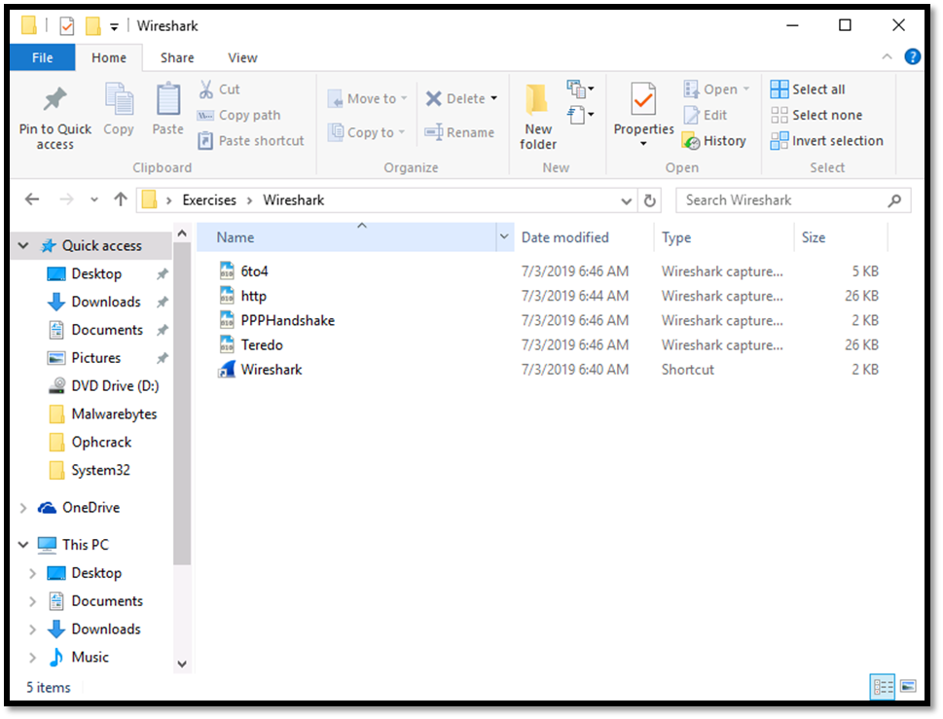

Once Wireshark starts go to File -> Open and select the file called http form the folder Exercises -> Wireshark 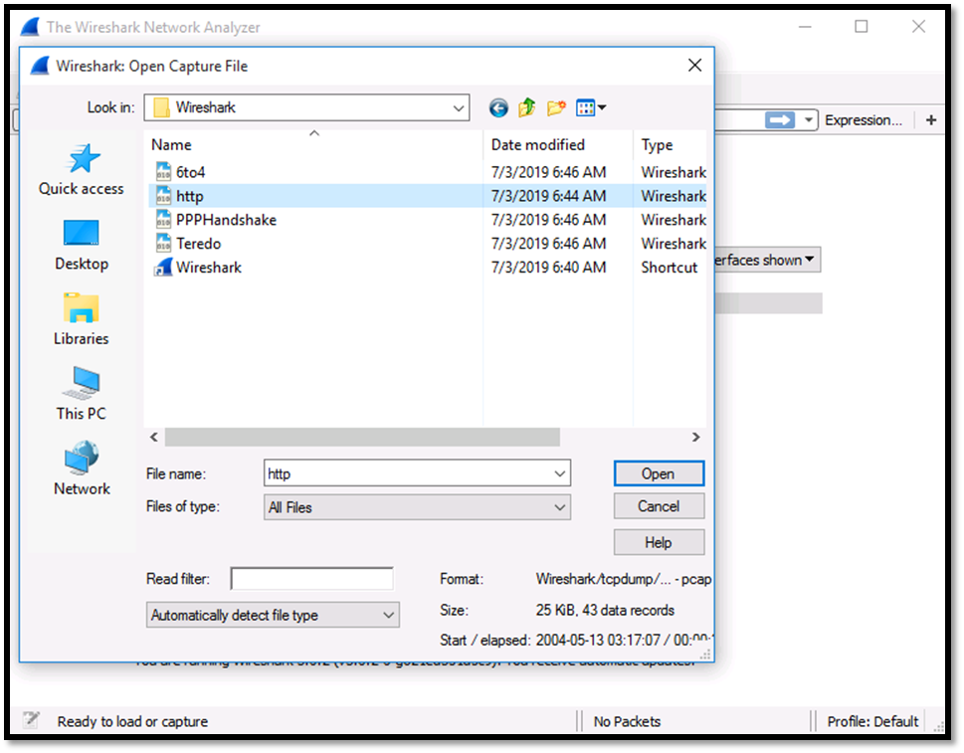

Once the file opens, locate the Source and Destination IPv4 addresses. These should be 145.254.160.237 and 65.208.228.223. Determine the Source Port and the Destination Port. These should be 3372 and 80 respectively.

Determine the Source Port and the Destination Port. These should be 3372 and 80 respectively.

**Helpful Links**

1. [https://linuxhint.com/install_wireshark_ubuntu/#:~:text=Installing%20Wireshark%3A,is%20really%20easy%20to%20install.&text=The%20APT%20package%20repository%20cache%20should%20be%20updated](https://linuxhint.com/install_wireshark_ubuntu/" \l ":~:text=Installing Wireshark%3A,is really easy to install.&text=The APT package repository cache should be updated)[.](https://linuxhint.com/install_wireshark_ubuntu/" \l ":~:text=Installing Wireshark%3A,is really easy to install.&text=The APT package repository cache should be updated.)

2. <https://itsfoss.com/install-wireshark-ubuntu/>